Ch 17 - Thermochemistry
http://www.dpi.state.nc.us/accountability/common-exams/released-forms/high?grades=High School&&category=Science
17.1 The Flow of Energy—Heat and Work

First Law of Thermodynamics (The Law of Conservation of Energy):
Energy is never created or destroyed; it can only change forms.
ENERGY LOST = ENERGY GAINED (-q_{lost}) = (+q_{gain})
Temperature
- Measure of the Average Kinetic Energy (average energy in motion)
- T = KE
- T = KE
- Indicates the direction of heat flow
      - Units: Kelvin (K), Celsius (°C)

Heat (q)
- Heat = Energy
- A substance loses or gains heat because of a temperature difference
- Heat travels - always flows from a warmer object to a cooler object.
      - Units: Joules (J), calories (cal) 4.184 J = 1 cal 1 J = 0.2390 cal

Potential Energy Diagrams and Enthalpy (Video)

Enthalpy (ΔH)- amount of energy (heat) in a reaction (absorbed or released)

- Exothermic- system loses heat (energy), surroundings heat up=heat released
(q, ΔH < 0; - value); ex. Hot hands

- Endothermic- system gains heat(energy), surroundings cool down=heat absorbed
(q, ΔH > 0; + value); ex. Cold pack

Specific Heat capacity:
  - Amount of heat it takes to raise the temp. of 1g 1° C
q = mC_{p}ΔT
      - q = heat in J
      - m = mass in g
      - Cp = specific heat capacity in J/g°C
      - ΔT = change in temperature in °C or K

ex. 1 If you drink a cold glass of water (250 g) at 0° C, how much heat is transferred to
the water as it warms to 37° C. The specific heat of water is 4.187 J/g°C
q= ?
m = 250 g
Cp = 4.187 J/g°C
ΔT = 37 – 0 = 37 °C
q= (250 g) (4.187 J/g°C) (37°C) = 3.87 x 10⁴ J

ex 2. The temp. of a 95.4 g piece of Cu increases from 25°C to 48.0°C when the Cu absorbs
849 J of heat. What is the specific heat of Cu?
q= 849 J
m = 95.4g
Cp = ?
ΔT = 48-25 = 23 °C
849 J = (95.4 g) C_{p} (23.0 °C)
849 J = (95.4 g) C_{p} (23.0 °C)
(95.4 g)(23.0 °C)
C_{p} = .387 J/g°C

17.3 Heat in Changes of State

Latent Heat:
- Heat (energy) absorbed or released to change the state of matter, at a
constant temperature and pressure

Latent heat of fusion (H_{f}):

- Heat required (absorbed) to melt (endothermic)
q = mH_{f} (heating curve)

ex. How many grams of ice at O °C will melt if 2.25 kJ of heat is added?
q= 2250J 2250 J = m 334 J/g
m= ? 334 J/g 334 J/g
H_{f}= 334J/g m = 6.74 g

Latent heat of solidification (exothermic)
q= m –H_{f} (cooling curve)

Latent heat of vaporization (H_{v})

- Heat required (absorbed) to vaporize (endothermic)
q= mH_{v} (heating curve)

ex. How much heat is absorbed (in J) when 24.8 g water at 100 °C and 101.3 kPa
is converted to steam at 100 °C
q= ? q= (24.8g) (2260J/g)
m= 24.8 g q= 56048 J
H_{v}= 2260J/g

Latent heat of condensation (exothermic)
q= m –H_{v} (cooling curve)

Heating/Cooling Curve:
- Shows phase changes:
  - flat spots- change in state of matter and potential energy; no change in
temperature or kinetic energy
  - slopes- no change in state of matter; change in temperature and kinetic energy

- Heating Curves- absorb heat/energy (endothermic, + value); melting, vaporization
- Cooling Curves- release heat/energy (exothermic, -value); freezing, condensation
- Heat energy and temperature proportional EXCEPT during state of matter changes

Heating Curve
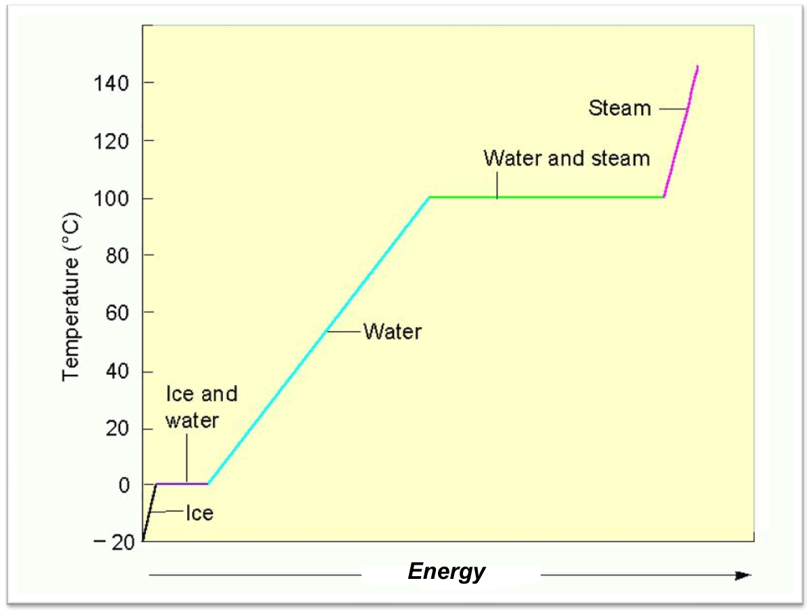

Summary of Heat Calculations:
- Heat required/exchanged to change temperature; Specific Heat q = m C_{p} ΔT
- Change of state: Solid liquid (melting) q = mH_{f}
Liquid solid (freezing) q = m⁻H_{f}
- Change of state: Liquid gas (boiling) q= mH_{v}
Gas Liquid (condensing) q= m⁻H_{v}

