**Ch. 25 Nuclear Chemistry**

**Nuclear Reactions:**

**Nuclear Reactions vs. Ordinary Chemical Reactions:** [**crash course video**](http://www.youtube.com/watch?v=KWAsz59F8gA)

**Chemical Reactions:**

* Rxns that involve the outer electrons
* Elements do not change from one to another.

Ex. 2H2 + O2 🡪 2H2O

**Nuclear Reactions:**

* Rxns that involve the nucleus
* Nucleus changes- products

can be different elements

than the reactants.

Ex. 🡪 +

**[Radioactivity:](http://ed.ted.com/on/Kz2hi5xn)**

* Process by which nuclei emit particles and rays (radiation)

[**Radiation:**](http://www.youtube.com/watch?v=TJgc28csgV0)

* Penetrating rays and particles emitted by a radioactive source

1. Alpha (α) – stopped by paper, skin, clothing
2. Beta (β)- stopped by metal foil, wood
3. Gamma (****)- stopped by lead, thick concrete

**Radioisotope:**

* An isotope that has an unstable nucleus
* Undergoes **radioactive decay** –spontaneous decay of the nucleus into

a more stable nucleus, emits particles +/or radiation

**Types of Radioactive Decay (Transmutation):**

* Sum Reactant’s Atomic # and mass # = Sum Product’s atomic # and mass #

Ex. ${}_{4}^{9}{Be}$ + ${}_{2}^{4}{He}$ → ${}_{6}^{12}C$ + ${}_{0}^{ 1}n$

* IF Atomic # changes = identity of element changes
* **Emission/Decay**= release particle/radiation. Product side of rxn
* **Capture**= takes in particle/radiation. Reactant side of rxn
  + **Alpha** **(α) ${}_{2}^{4}{He}$**

Ex. ⭢ +

* + **Beta/Electron** **($β$) ${}_{-1}^{0}{e }$**

Ex. ⭢ +

* + **Gamma ($γ$) \***No particles are emitted

Ex. ⭢ +

* + **Positron ($β$) ${}_{+1}^{0}e$**

Ex. ⭢ +

* + **Neutron ${}_{0}^{1}n$**

Ex. + ⭢

* + **Proton ${}_{1}^{1}H$**

Ex. ⭢ +

[**Artificial Transmutation**:](https://www.youtube.com/watch?v=G6mmIzRz_f8)

* Particles bombard the nucleus of an atom
* Particle accelerator (Atom Smasher), Nuclear reactors, Nuclear bombs
* Elements above 92 = man-made

ex.

+ ⭢ +

+ ⭢ ⭢ +

[Higgs-boson (crazy girl)](http://www.huffingtonpost.com/2012/07/03/higgs-boson-video_n_1646116.html)

[**Higgs-boson Ted ED cartoon**](http://www.youtube.com/watch?v=IElHgJG5Fe4)

[**Higgs-boson Explanation cartoon\***](https://www.youtube.com/watch?v=joTKd5j3mzk)

[**More Higgs-boson explanation**](http://www.youtube.com/watch?v=RIg1Vh7uPyw&feature=related)**\***

[**http://ed.ted.com/lessons/brian-cox-on-cern-s-supercollider**](http://ed.ted.com/lessons/brian-cox-on-cern-s-supercollider)**\*\***

[**Comparing Fission & Fusion**:](http://www.bbc.co.uk/schools/gcsebitesize/science/add_aqa/atoms_radiation/nuclearact.shtml)

**Fission:**

* Heavy nuclei are split into lighter nuclei.
* Relatively easy to control but produce radioactive wastes.
* [Plutonium and uranium](http://www.npr.org/blogs/krulwich/2012/07/17/156915881/if-you-are-hit-by-two-atomic-bombs-should-you-have-kids)

[**Fission**](http://www.youtube.com/watch?v=tQa4LONy9XM)

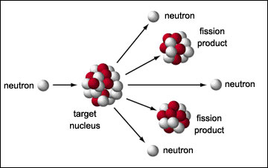

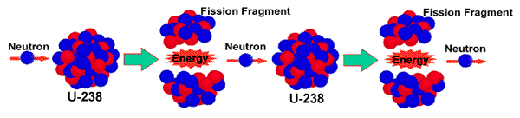

[Three mile Island](http://www.teachersdomain.org/asset/phy03_vid_threemile/)

[Chernobyl II](http://www.youtube.com/watch?v=fhYiOY6kKzo)

[Fukushima I](http://app.discoveryeducation.com/search?Ntt=nuclear)

[Fukushima TIME explanation](http://content.time.com/time/video/player/0,32068,833602970001_2059584,00.html)

[Chernobyl postcard pics](https://vimeo.com/112681885)

[Nuclear bomb b](https://www.youtube.com/watch?v=fIbACkLU-38)

**Fusion:**

* Light nuclei are combined to form heavier nuclei.
* Difficult to initiate and control but produce little radioactive wastes.

[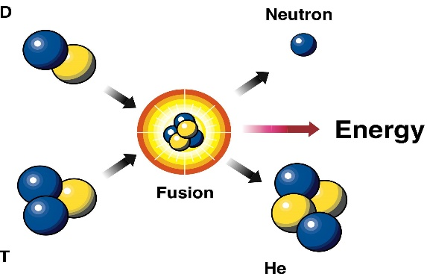](http://iter.rma.ac.be/en/img/FusionReaction.jpg)

[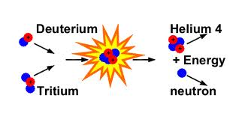](http://www.google.com/imgres?q=fusion&um=1&hl=en&sa=N&qscrl=1&nord=1&rlz=1T4ADSA_enUS430US431&biw=1024&bih=556&tbm=isch&tbnid=9DS12NV3XM7JVM:&imgrefurl=http://www.plasma.inpe.br/LAP_Portal/LAP_Site/Text/Fusion_Reactions.htm&docid=FdvzMFanjxs-VM&imgurl=http://www.plasma.inpe.br/LAP_Portal/LAP_Site/Figures/Fusion_Reaction.gif&w=540&h=270&ei=tD0xT8r3As-3tweZzbHsBg&zoom=1)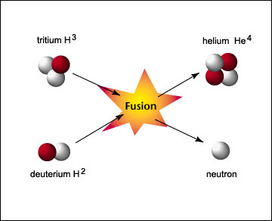

[**Half-Life**](http://ed.ted.com/on/WeYs57UP)**:**

* Time it takes for ½ of the atoms of a radioactive isotope to decay
* More stable isotopes – decay slowly → longer ½ life
* Less stable isotopes- decay quickly → shorter ½ life

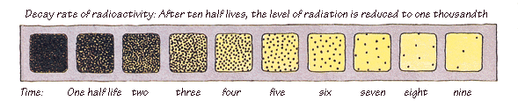

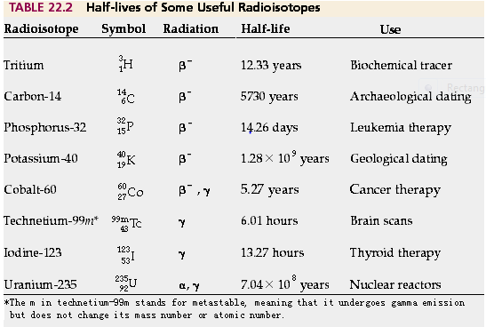

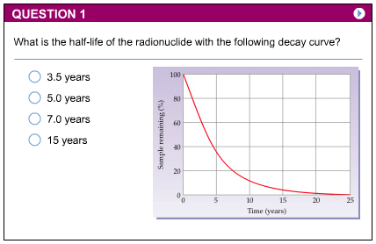

**Calculating Half-Life:**

**Ex. 1** Radioactive element has a ½ life of 30 days of an 8 gram sample,

how much will be unchanged after 90 days?

**½life Time** **Unchanged (Parent) Changed (daughter)**

0 0 8 grams (0grams)

1st 30 days 4 grams (4 grams)

2nd 60 days 2 grams (6 grams)

3rd 90 days 1 gram (7 grams)

**Ex. 2** The following is known about a fossil bone:

# a.) Amount of carbon-14 originally in bone = 800g

# b.) Amount of carbon-14 presently in bone = 100g

# c.) Amount of nitrogen-14 presently in bone = 700g

d.) half-life = 5,730 yrs

How old is the fossil bone?

*17,190 yrs*

**½ life Time P (C-14) D (N-14)**  0 0 yrs 800g 0g

1st 5,730 yrs 400g 400g

2nd 11,460 yrs 200g 600g

3rd 17,190 yrs 100 g 700g

**Ex.3** The ½ life of radium-224 is 3.66 days. What was the original

mass of radium-224 if 0.0500 grams remain after 7.32 days?

**Amount remaining= (initial amount)(.5) n**

**n= t/T**

**t=time elapsed**

**T=length of ½ life**

**n= # of ½ lives**

soo….

n=7.32/3.66

n= 2

0.0500g=X(.5)2  = 0.0500=x(.25)

.25 .25

X= .2 grams