Chapter 2: Matter and Change

Physical vs. Chemical Change:

Physical Change:
- Properties may change, chemical composition does not (no new substance forms)
Ex. Melt, boil, freeze, condense, break, split, grind, cut, crush

Chemical Change (reactions):
- One or more substances combine or breakdown
- Composition (ID) of matter changes, new substance forms

Reactant Product

Indicators of Chemical rxn:
- Formation of a precipitate
- Formation of a gas
- Color change
- Absorption or release of heat
- Formation of Light

Law of Conservation of Mass:
- Mass is neither created nor destroyed
- Mass of the reactant(s) = Mass of product(s).

Practice Problem:
If 44 grams of carbon dioxide react completely w/ 18 grams of water, what is the mass of carbonic acid formed?

In an engine, octane combines with oxygen to form carbon dioxide and water. If 22.8 grams of octane combine completely w/ 80 grams of oxygen to form 70.4 g carbon dioxide, what mass of water is formed?

Matter:
- Anything that has mass and takes up space

Extensive Properties:
- Depend on the amt. of matter
Ex. Mass, volume

Intensive Properties:
- Depend on the type of matter
Ex. Hardness, Color, solubility, odor, density,
melting/boiling/freezing points

Types of Matter:

A.) Substance:
- Uniform, fixed composition $∴$can’t separate by physical means
    - Identical intensive properties
Ex. Gold (Au), Copper (Cu), Water (H₂0)

Element:
- Simplest form of matter -made of only 1 kind of atom
- 100 + known
- Represented by symbols (first letter = capitalized) ex. Na
Ex. Oxygen (O), Hydrogen (H)
Compound:
- Substance that contains 2 or more elements chemically bonded
- Properties different from their component elements
- Represented by formulas ex. H₂O
Ex. NaCl (sodium chloride)

B.) Mixture:
- Physical blend of 2 or more components (ex.Salad)
- Composition varies $∴$ can separate by physical means
- Phase- Any part of a sample w/ uniform composition and properties

Classifying Mixtures:
Heterogeneous Mixtures (Suspensions):
- 2 or more phases (not uniform)

Homogeneous Mixture (Solutions):
- 1 phase (uniform)

Separating Mixtures:

Filtration:
- Separating a solid from a liquid in a heterogeneous mixture

Distillation:
- Separating a solid from a liquid in a homogenous mixture

Chromatography
- Separating homogenous mixtures like ink, pigments

States of Matter: They might be giants

Property | Solid | Liquid | Gas
Shape | Definite | Indefinite | Indefinite
Volume | Definite | Definite | Indefinite
Expansion | N/a | Moderate | Great
Compressibility | N/a | N/a | very
Kinetic Energy | Low | Medium | High

13.4 Changes of State
Kinetic Molecular Theory
- thermodynamic behavior of matter, especially the relationships among pressure, volume, and temperature in gases
- Temperature, kinetic energy

Entropy:
- A measure of the disorder of a system.
- Increasing entropy = s → l → g
- Law of Disorder -states that the natural tendency is for systems to move in the direction of maximum disorder or randomness

Phase diagram:
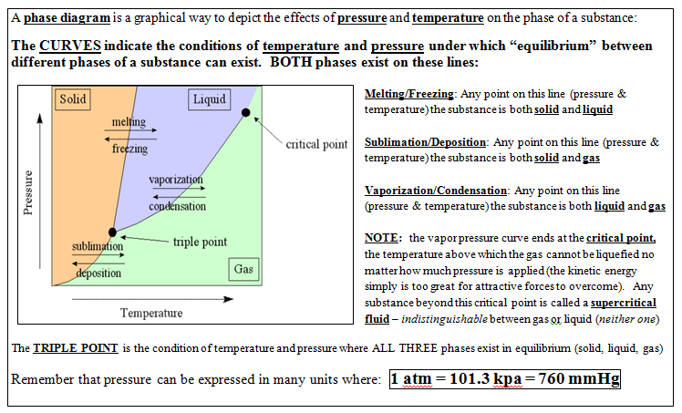

Water vs. CO₂ Phase diagrams

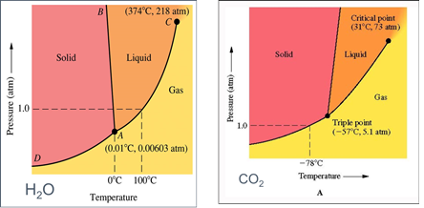

*Sublimation = solid to gas; atmospheric pressure is too low to stop molecules
from escaping the solid phase; atmospheric pressure less than vapor pressure

*If the solid phase is more dense than the liquid phase. The line that separates
solid and liquids bends right (like in CO₂)

*IF the solid phase is less dense than the liquid phase. The line that separates
solid and liquids bends left (like in water. So when the pressure increases on
ice it will melt).

