Ch 5 - Electrons in the Atom

The Bohr Model: (1913)

- Electrons move only in specific orbits (Energy levels) around the nucleus
- Quantum- unit of energy
- Quantum Jump- energy needed to move electrons from 1 energy level to
the next

Development of the Modern Atomic Model:
- Grew from the study of light

Louis de Broglie (1923):
- Electrons – both wave and particle like properties (Wave/particle duality)
Dr. Quantum video
Properties of Light:
- Consists of waves
- Photon– quantum of light
- Wavelength (λ)- distance b/w crests (nm or m) (10⁹ nm = 1m or 10⁻⁹ m = 1nm)
- Frequency (ν) - # of λ to pass a given point per a unit of time (Hz or s⁻¹)
- λ ↑, ν ↓
c =λν (c= speed of light 2.998 x 10⁸ m/s)

http://www.astronomynotes.com/light/s3.htm

- Electromagnetic Radiation- form of energy (photon) that exhibits wavelike behavior
(Radio, microwaves, infrared, visible light, ultraviolet, x-rays, gamma rays)

Electromagnetic Spectrum

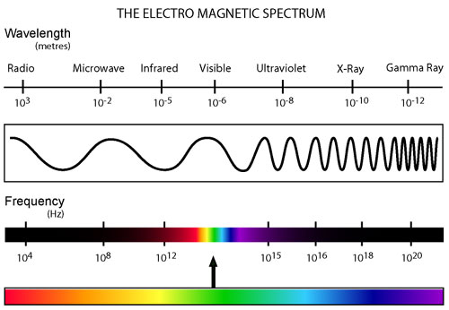

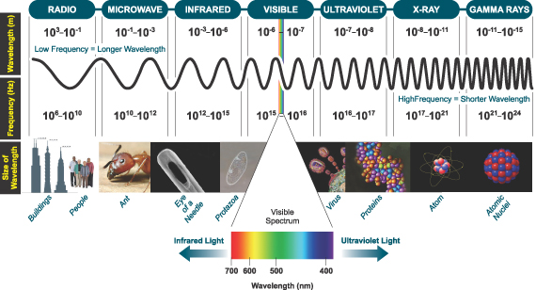
I:\Chemistry\chemistry reference table.pdf

Atomic Spectra:
- Emission Spectrum – frequencies of light separated into individual lines
(colors) (ex. Red –lowest ν, longest λ; violet – highest ν, shortest λ)
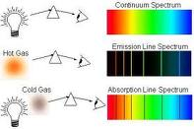

Explanation of Atomic Spectra:
- Electrons absorbs energy = “quantum jump” to higher energy level – excited state
- Electrons lose energy = electrons transition back to lower energy level- ground state and emits light (photon)
- Each transition = specific frequency in the spectrum
- Amount of energy determines frequency (and therefore color emitted)
- Frequency directly proportional to the energy change
http://astro.u-strasbg.fr/~koppen/discharge/nitrogen.html

Hydrogen spectrum = produced 3 groups of lines based on electrons transitions:
Lyman series – down to the 1st energy level (UV range)
Balmer series – down to the 2nd energy level; (Visible range)
Paschen series- down to the 3rd energy level; (IR range)
I:\Chemistry\chemistry reference table.pdf

Quantum Mechanics:

Werner Heisenberg (1925):
- Matrix Mechanics
- Electrons- quantum jumps

Erwin Schrodinger (1926):
- Schrodinger Wave Equation
- Electrons- continuous waves of energy

Heisenberg Uncertainty Principle (1927):
- Can’t tell the position and velocity (speed) of an electron at same time
- Led to Quantum Mechanical Model

Quantum Mechanical Model (Electron Cloud Model):
- No exact path for electrons – Probability regions instead
- Mathematical expression
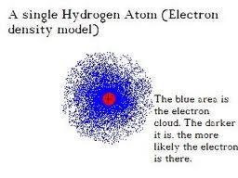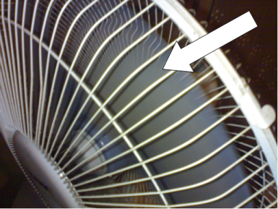

Quantum leap lab results

Atomic Orbital:
- Principle Energy levels (n)= 1, 2, 3, 4, 5, 6, 7
- "Probability regions” –fuzzy clouds – regions where electrons can be found – most dense where probability is high (closest to the nucleus)
- Divided into sublevels and orbitals (max. of 2 electrons per)
    - s– spherical shaped (1 orbital)
    - p - dumbbell shaped (3 orbitals)
    - d –varies (5 orbitals)
    - f - varies (7 orbitals)

Table 1: 1st 4 Principle Energy levels:
Principle energy levels  (n) | Sublevels per each principle energy level | Number of orbitals per sublevel | Number of orbitals per principle energy level (n²) | Number of electrons per sublevel | Number of electrons per principle energy level (2n²)
1 | s | 1
2 | s  p | 1  3
3 | s  p  d | 1  3  5
4 | s  p  d  f | 1  3  5  7

Bohr vs. Quantum Mechanical Model:
- Both restricts the energy of electrons to certain values
- Bohr – electrons take an exact pathway around the nucleus
- Quantum – electrons do NOT have an exact pathway around the nucleus rather probability regions

5.2 Electron Arrangement in Atoms:

Electron Configurations: electron energy level song
- Ways in which electrons are arranged in energy levels around the nucleus

Aufbau Principle:
- Electrons occupy the lowest energy level first (1 is lowest).
- s sub-level always the lowest within an energy level (n)

Pauli Exclusion Principle:
- Each orbital can have max. of 2 electrons
- Opposite spins in same orbital
- Vertical arrow indicates direction of spin (↑ or ↓)
- Orbital containing paired electrons written as ↑↓

Hund’s Rule:
- Electrons within the same sublevel (ex. 3p)- 1 electron enters each orbital until all orbitals contain electrons with same spin, then 2nd electrons can be added if necessary
Ex. Orbital Notation for C
2s ↑↓ 2p ↑_ ↑_ __
1s ↑↓

orbital notation filling order chart

Writing Electron Configurations: electron energy level song
- # = principle energy level
- Letter = sublevel
- Superscript = # of electrons within that sublevel
- Sum of superscript = atomic # for that element
Long Form:
- Write entire configuration
Ex. Na = 1s²2s²2p⁶3s¹
Short Form (abbreviated form):
- Use Noble gas configurations (far right column)
- Put the Noble gas element symbol closest to the element you are
writing (the preceding row’s noble gas) in brackets and continue with
the rest of the configuration
Ex. Na = [Ne]3s¹
Neon and sodium’s long form: Ne = 1s²2s²2p⁶
Na = 1s²2s²2p⁶3s¹

^{Periodic Table Rule:}

Periods (rows)= energy levels
Exceptions: Period 4 - columns 3-12 = 3 energy level ^{(3d)}
Period 5 - column 3-12 = 4 energy level (4d)
Period 6 - column 3-12 = 5 energy level (5d)
Period 7 - column 3-12 = 6 energy level (6d)

* (bottom 2 rows of elements = 4f, 5f)

Groups (Columns)= sublevels
^{s sublevel = column 1-2 + He}
^{p sublevel = column 13-18}
^{d sublevel = column 3-12}
^{f sublevel = bottoms rows}
**Read across the periodic table to determine the configurations. Count the
elements per energy level (row) and sublevel (column) -that # will equal the
superscript ( # of electrons) for that energy and sublevel.

Ex. Oxygen = 1s²2s²2p⁴
1 s² = energy level 1 (row 1), sublevel s (column 1+2), 2 electrons (2 elements)
2s² = energy level 2 (row 2), sublevel s (column 1+2) 2 electrons (2 elements)
2p⁴ = energy level 2 (row 2), sublevel p (column 13-18) 4 electrons (4 elements)

^{Correct filling order:}
1s 2s 2p 3s 3p 4s 3d 4p 5s 4d 5p 6s 4f 5d 6p 7s 5f 6d 7p 6f 7d 7f
blank periodic table
periodic table
Spdf periodic table

Diagonal Rule:
Correct filling order – after energy level 2, things get tricky!!

1s²
2 s² 2p⁶
3 s² 3p⁶ 3d¹⁰
4 s² 4p⁶ 4d¹⁰ 4f¹⁴
5 s² 5p⁶ 5d¹⁰ 5f¹⁴
6 s² 6p⁶ 6d¹⁰ 6f¹⁴
7 s² 7p⁶ 7d¹⁰ 7f¹⁴

^{Correct filling order:}
1s 2s 2p 3s 3p 4s 3d 4p 5s 4d 5p 6s 4f 5d 6p 7s 5f 6d 7p 6f 7d 7f

