**Ch 7: Cell Structure and Function**

**Ch 7.1** [**Life is Cellular**](http://learn.genetics.utah.edu/content/cells/scale/)**:**

[**Microscopes:**](http://www.classzone.com/cz/books/bio_09/resources/htmls/animated_biology/unit1/bio_ch01_0021_ab_cells.html)

1. **Light microscope:**

* Produces magnified images by focusing visible light

1. **Electron microscope:**

* Uses electrons with shorter wavelengths than light
* 2 types:
  + - 1. TEM- transmission – inside the cell

2. SEM- scan – outside the cell 3D images

1. **Scanning probe microscopes:**

* Trace the surface of the sample with a fine probe

**Robert Hooke:**

* mid-1600’s
* Viewed cork (plant material) –saw empty chambers “cells”

[**Cell theory states**](http://ed.ted.com/lessons/the-wacky-history-of-cell-theory)**:**

1. All living things are composed of cells
2. Cells are the basic units of living things.
3. New cells from existing cells

**2 Types of Cells:**

**Prokaryotes:**

* Small, simple cells
* No nucleus – DNA free floating circular plasmids
* RNA
* No membrane bound organelles
* Ribosomes
* Cell wall contains peptidoglycan
* Cell membrane
* Cytoplasm
* Unicellular organisms

ex. bacteria.

**Eukaryotes:**

* Large, complex cells
* Nucleus- contains DNA
* RNA
* Membrane bound organelles (ex. Mitochondrion, ER, etc…)
* Ribosomes
* Cell wall does not contains peptidoglycan
* Cell Membrane
* Cytoplasm
* Unicellular and multicellular organisms

ex. Protists, Fungi, Animal and Plant cells

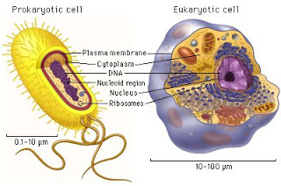

Foldable- pro vs. euk

**Ch 7.2 Cell Structures:** [**http://amit1b.wordpress.com/the-molecules-of-life/10-the-living-cell-gallery/**](http://amit1b.wordpress.com/the-molecules-of-life/10-the-living-cell-gallery/)

**Parts of the Cell:**

**Cell wall** –support and protection in bacteria, plants, fungi, and some protists.

NOT FOUND IN ANIMAL CELLS.

**Cell membrane** (Plasma membrane) – regulates what enters and leaves the cell;

The Gate Keeper. Found in ALL cells.

**Cytoplasm** – gel-like substance

**Cytoskeleton** – supports the cell

**Cilia** – short projections; function in movement

**Flagella** – long projections; function in movement

**Organelles-** membrane bound structures; “little organs”

**Nucleus** –control center; contains DNA (eukaryotes only)

**Ribosomes** – make proteins; composed of RNA and proteins

**Endoplasmic reticulum** (ER) –lipids, proteins, and other materials assembled

and exported; highway to move stuff

**Rough ER** – has ribosomes; protein production

**Smooth ER** –no ribosomes; lipid production and detoxification.

**Golgi apparatus** –modify, sort, and package proteins/materials from the ER

**Lysosomes** –cells digestive system- cleanup crew

**Vacuoles** –storage (water, salts, proteins, carbs)

**Mitochondria** – convert food energy into cellular energy (ATP);

POWER HOUSE OF THE CELL; folded inner membrane= increased surface area for ATP production

**Chloroplasts** – in plants and some Protists, capture sunlight and convert it into

chemical energy -sugar (**photosynthesis**).

**Centrioles** – help organize cell division, (not found in plants).

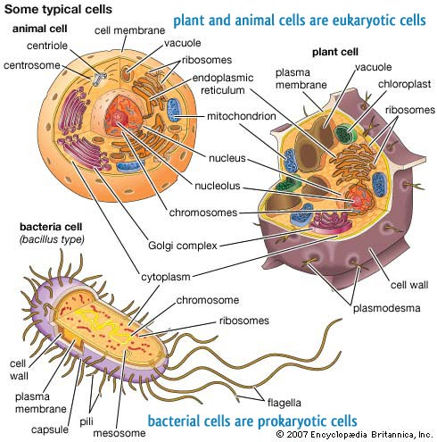

[**http://www.classzone.com/cz/books/bio_09/resources/htmls/animated_biology/unit2/bio_ch03_0074_ab_organelle.html**](http://www.classzone.com/cz/books/bio_09/resources/htmls/animated_biology/unit2/bio_ch03_0074_ab_organelle.html)

FRAME- cells

Foldable- plant vs. animal

**Ch 7.3 Cell Boundaries:**

[**Cell membrane**](cell%20membrane%20pictures.flipchart)**:**

* Regulates what enters and leaves the cell
  + [Lipid bilayer](http://ed.ted.com/on/TfUHVLl3) (phospholipid)- flexibility and barrier (selectively permeable)
  + Proteins – channels and pumps
  + Carbohydrates – act like chemical identification cards

**[Movement across the Cell membrane:](http://www.youtube.com/watch?v=yAXnYcUjn5k)**

**Concentration** – mass of solute/volume of solvent

1. **Passive Transport:**

* Spontaneous, random movement of particles from an area of higher concentration to lower concentration
* Continues even after equilibrium is met
* **Requires NO energy**

1. **Diffusion:**

* Movement of **particles (solutes)** across the cell membrane from

an area of high concentration to an area of low concentration

1. **Facilitated Diffusion:**

* Movement of **particles (solutes)** across the cell membrane

through **protein channels** from an area of high concentration

to an area of low concentration

1. **Osmosis:**

* Movement of **water** across the cell membrane from an area of high concentration to an area of low concentration

**Isotonic:**

* + Equal solute concentrations on both sides of the cell membrane (“same strength”)

**Hypertonic:**

* + Higher solute concentration
  + More concentrated (“above strength”) solution than cell
  + Cell shrinks

**Hypotonic:**

* + Less solute concentration
  + Less concentrated (“below strength”) solution than cell
  + Cell swells

[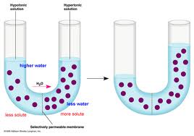](http://www.google.com/imgres?q=osmosis&um=1&hl=en&sa=N&rlz=1W1ADSA_en&biw=1024&bih=556&tbm=isch&tbnid=AqALyzRVcodOuM:&imgrefurl=http://www.biologycorner.com/bio1/diffusion.html&docid=Von3PeQFzhiKqM&w=605&h=425&ei=VPVcTsLMGtLogQfq__HvAQ&zoom=1)

1. **Active Transport:**

* Movement of **particles** across the cell membrane against concentration difference (low to high)
* Uses transport proteins (“pumps”)
* **Requires energy**

1. **Endocytosis:**

* Taking material into a cell by engulfment

**B.) Exocytosis**

* Releasing material from a cell

FRAME -cell membrane

**Ch 7.4 Diversity of Cellular life:**

**Unicellular Organisms:**

* One cell = organism

ex. Bacteria and many Protists.

**Multicellular Organisms:**

* Many cells = organism
* Cells are specialized

ex. Humans

[**Cell Differentiation** **or Cell Specialization:**](http://glencoe.mcgraw-hill.com/sites/dl/free/0078617022/164155/00035805.html)

* Cells develop in alternative ways to perform different tasks

ex. Red blood cells are specialized to transport oxygen

Pancreatic cells produce certain proteins

Guard cells in plants open and close the stomata

[Cell Communication:](http://www.youtube.com/watch?v=U6uHotlXvPo)

* Cells communicate by sending and receiving signals
* Signals may come from the environment, or they may come from other cells
* To trigger a response, signals must be transmitted across the cell membrane

**Levels of organization****:**

**http://www.docstoc.com/docs/124223658/Organization-of-the-Body**

**Cell** –collection of living matter enclosed by a barrier; basic unit of life

**Tissue** – group of similar cells that perform a particular function

**Organ** – many groups of tissues work together to function as an organ

**Organ system** – a group of organs that work together to perform a

specific function, like digestion