Ch 5 - Electrons in the Atom

The Bohr Model: (1913)
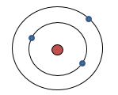
- Electrons -specific orbits (Energy levels) around the nucleus
- Quantum- unit of energy
- Quantum Jump- energy needed to move electrons from 1 energy
level to the next

Development of the Modern Atomic Model:
- Grew from the study of light

Properties of Light:
- Consists of waves
- Photon– quantum of light
- Wavelength (λ)- distance b/w crests (nm or m) (10⁹ nm = 1m or 10⁻⁹ m = 1nm)
- Frequency (ν) - # of λ to pass a given point per a unit of time (Hz or s⁻¹)
- λ ↑, ν ↓
c =λν (c= speed of light 2.998 x 10⁸ m/s)

http://earthguide.ucsd.edu/eoc/special_topics/teach/sp_climate_change/p_emspectrum_interactive.html
http://www.astronomynotes.com/light/s3.htm

- Electromagnetic Radiation- form of energy (photon) that exhibits wavelike behavior
(Radio, microwaves, infrared, visible light, ultraviolet, x-rays, gamma rays)

Electromagnetic Spectrum

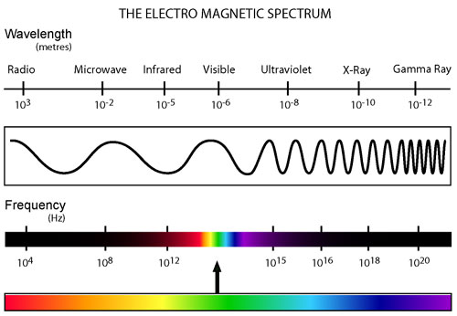

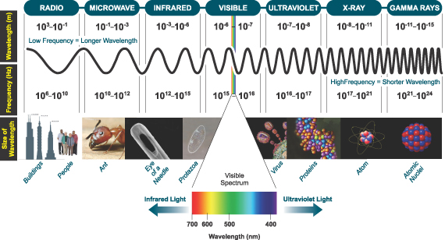
I:\Chemistry\chemistry reference table.pdf

Atomic Spectra:
- Emission Spectrum – frequencies of light separated into
individual lines (colors)
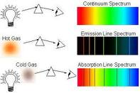

Explanation of Atomic Spectra:
- Electrons absorbs energy = “quantum jump” to higher energy
level – excited state
- Electrons lose energy = electrons fall back to lower energy
level- ground state and emits light (photon)
- Each transition = specific frequency in the spectrum (color)
- Frequency directly proportional to the energy change

Hydrogen spectrum = produced 3 groups of lines based on electrons transitions:
Lyman series – down to the 1st energy level (UV range)
Balmer series – down to the 2nd energy level; (Visible range)
Paschen series- down to the 3rd energy level; (IR range)
I:\Chemistry\chemistry reference table.pdf

Quantum Mechanics:

Louis de Broglie (1923):
- Electrons – both wave and particle like properties (Wave/particle duality)

Werner Heisenberg (1925):
- Matrix Mechanics
- Electrons- quantum jumps

Erwin Schrodinger (1926):
- Schrodinger Wave Equation
- Electrons- continuous waves of energy

Heisenberg Uncertainty Principle (1927):
- Can’t tell the position and velocity (speed) of an electron at same time
- Led to Quantum Mechanical Model

Quantum Mechanical Model (Electron Cloud Model):
- No exact path for electrons – Probability regions instead
- Mathematical expression
(Max Born won the 1954 Nobel Prize in Physics for his "fundamental research in Quantum Mechanics, especially in the statistical interpretation of the wave function)
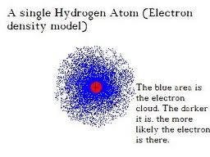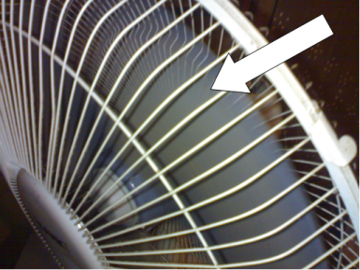

Quantum leap lab results

Atomic Orbital:
- Principle Energy levels (n)= 1, 2, 3, 4, 5, 6, 7
- "Probability regions” –fuzzy clouds – regions where electrons can be found – most dense where probability is high (closest to the nucleus)
- Divided into sublevels and orbitals (max. of 2 electrons per orbital)
    - s– spherical shaped (1 orbital)
    - p - dumbbell shaped (3 orbitals)
    - d –varies (5 orbitals)
    - f - varies (7 orbitals)

Table 1: 1st 4 Principle Energy levels:
Principle energy levels  (n) | Sublevels per each principle energy level | Number of orbitals per sublevel | Number of orbitals per principle energy level (n²) | Number of electrons per sublevel | Number of electrons per principle energy level (2n²)
1 | s | 1
2 | s  p | 1  3
3 | s  p  d | 1  3  5
4 | s  p  d  f | 1  3  5  7

Bohr vs. Quantum Mechanical Model:
- Both restricts the energy of electrons to certain values
- Bohr – electrons take an exact pathway around the nucleus
- Quantum – electrons do NOT have an exact pathway around the nucleus rather probability regions

5.2 Electron Arrangement in Atoms:

Electron Configurations:
- Ways in which electrons are arranged in energy levels around the nucleus

Aufbau Principle:
- Electrons occupy the lowest energy level first (1 is lowest).
- s sub-level always the lowest within an energy level (n)

Pauli Exclusion Principle:
- Each orbital can have max. of 2 electrons
- Opposite spins in same orbital
- Vertical arrow indicates direction of spin (↑ or ↓)
- Orbital containing paired electrons written as ↑↓

Hund’s Rule:
- Electrons within the same sublevel (ex. 3p)- 1 electron enters each orbital until all orbitals contain electrons with same spin, then 2nd electrons can be added if necessary
Ex. Orbital Notation for C
2s ↑↓ 2p ↑_ ↑_ __
1s ↑↓

orbital notation filling order chart

Writing Electron Configurations: electron energy level song
- # = principle energy level
- Letter = sublevel
- Superscript = # of electrons within that sublevel
- Sum of superscript = atomic # for that element
Long Form:
- Write entire configuration
Ex. Na = 1s²2s²2p⁶3s¹
Short Form (abbreviated form):
- Use Noble gas configurations (far right column)
- Put the Noble gas element symbol closest to the element you are
writing (the preceding row’s noble gas) in brackets and continue with
the rest of the configuration
Ex. Na = [Ne]3s¹
Neon and sodium’s long form: Ne = 1s²2s²2p⁶
Na = 1s²2s²2p⁶3s¹

^{Periodic Table Rule:}

Periods (rows)= energy levels
Exceptions: Period 4 - columns 3-12 = 3 energy level ^{(3d)}
Period 5 - column 3-12 = 4 energy level (4d)
Period 6 - column 3-12 = 5 energy level (5d)
Period 7 - column 3-12 = 6 energy level (6d)

* (bottom 2 rows of elements = 4f, 5f)

Groups (Columns)= sublevels
^{s sublevel = column 1-2 + He}
^{p sublevel = column 13-18}
^{d sublevel = column 3-12}
^{f sublevel = bottoms rows}
**Read across the periodic table to determine the configurations. Count the
elements per energy level (row) and sublevel (column) -that # will equal the
superscript ( # of electrons) for that energy and sublevel.

Ex. Oxygen = 1s²2s²2p⁴
1 s² = energy level 1 (row 1), sublevel s (column 1+2), 2 electrons (2 elements)
2s² = energy level 2 (row 2), sublevel s (column 1+2) 2 electrons (2 elements)
2p⁴ = energy level 2 (row 2), sublevel p (column 13-18) 4 electrons (4 elements)

^{Correct filling order:}
1s 2s 2p 3s 3p 4s 3d 4p 5s 4d 5p 6s 4f 5d 6p 7s 5f 6d 7p 6f 7d 7f
blank periodic table
periodic table
Spdf periodic table

Diagonal Rule:
Correct filling order – after energy level 2, things get tricky!!

1s²
2 s² 2p⁶
3 s² 3p⁶ 3d¹⁰
4 s² 4p⁶ 4d¹⁰ 4f¹⁴
5 s² 5p⁶ 5d¹⁰ 5f¹⁴
6 s² 6p⁶ 6d¹⁰ 6f¹⁴
7 s² 7p⁶ 7d¹⁰ 7f¹⁴

^{Correct filling order:}
1s 2s 2p 3s 3p 4s 3d 4p 5s 4d 5p 6s 4f 5d 6p 7s 5f 6d 7p 6f 7d 7f

