Honors Chemistry II- Article
Claims, Evidence, Reasoning and Reflection

Claim-A statement or conclusion that answers the original question/problem.
Evidence-Scientific data that supports the claim. The data needs to be appropriate and sufficient to support the claim.
Reasoning-A justification that connects the evidence to the claim. It shows why the evidence supports the claim.

Your task:
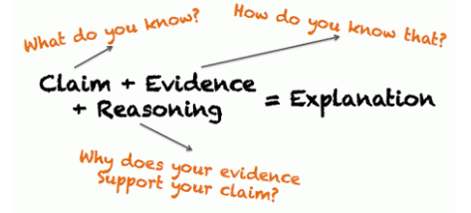

- Read the article provided and pick out two claims.
- Search the article for evidence to support these claims.
- Provide a justification for each of your claims (how does the evidence support the claim).
- Reflection (likes, dislikes, what you learned, significance, etc..) (~ 3 sentences)

C.E.R.R. Claims, Evidence, Reasoning and Reflection-Outline Format
Claim A (article)
Evidence A (synthesis from article)
Reasoning A (your noggin’)

Claim B (article)
Evidence B (synthesis from article)
Reasoning B (your noggin’)

Reflection
C.E.R.R Rubric
Component | Level
 | 0 | 1 | 2
Claim- A statement or conclusion that answers the original question/problem.  What do you know? Claim A  Claim B | Does not make a claim, or makes an inaccurate claim. | Makes an accurate but incomplete claim. | Makes an accurate and complete claim.
Evidence-Scientific data that supports the claim. The data needs to be appropriate and sufficient to support the claim.  How do you know?  Evidence A  Evidence B | Does not provide evidence, or only provides inappropriate evidence (evidence that does not support the claim). | Provide appropriate but insufficient evidence to support claim. May include some inappropriate evidence. | Provides appropriate and sufficient evidence to support claim.
Reasoning-A justification that connects the evidence to the claim. It shows why the evidence supports the claim.  Why does your evidence support your claim?  Reasoning A  Reasoning B | Does not provide reasoning, or only provides reasoning that does not link evidence to claim | Provides reasoning that links the claim and evidence. Repeats the evidence and/or includes some-but not sufficient-scientific principles | Provides reasoning that links evidence to claim. Includes appropriate and sufficient scientific principles.
Reflection- likes, dislikes, what you learned, significance, etc.. (~ 3 sentences or more) | Does not provide a reflection. | Provides some reflective thoughts.  1-2 sentences. | Provides strong, reflective thoughts. ~ 3 sentences or more.
Reflection
Total
 |  |  | Grade | /14 =

