Name:
Study guide: Ch 3,2,13.4 C

Instruments:
- Record to measurements to the correct number of significant figures:
- 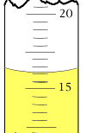 b.) 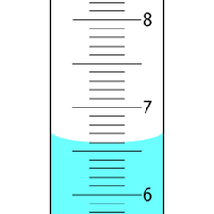c.) 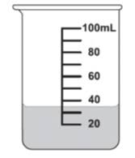

Percent Error:
- The solubility product constant for silver oxide at 25° C is actually 1.51 x 10⁻⁸. An experimental value obtained in a lab was 1.36 x 10⁻⁸. What is the percent error?

- A student analyzing a sample for bromine (Br) makes four trials with the following results: 35.2, 36.9, 35.2, and 36.5. The actual value is 36.2. What is the percent error?

Density:
- Limestone has a density of 2.72 g/cm³. What is the volume of 24.9 g of limestone?

- Use a calculator to determine the density of a pine board whose dimensions are
4.05 cm x 8.85 cm x 164 cm and whose mass is 2580 g.

- What is the volume of 7.57 kg of tin if its density is 7.28g/ml?

- Calculate the density of an object if its mass is 5.32 g and its volume is .745 cm³.

- Based on the density, identify the object from the previous question (# 4) (hint:
use your Chemistry Reference packet).

Matter and Change:
- How are physical and chemical changes different?

- List all the indicators of a chemical rxn.

- Susie reacted two clear, liquid chemicals together and produced a bright yellow solid. Did a physical or chemical change (rxn) occur? How do you know (what is the evidence?)

- Johnny light a metal strip and bright light was produced. Did a physical or chemical change (rxn) occur? How do you know (what is the evidence?)

- Danny put some mentos in Diet coke and coke shot out of the bottle. Did a physical or chemical change (rxn) occur? How do you know (what is the evidence?)

- What are the differences b/w a solid, liquid and a gas?

- What are substances?

- What are mixtures?

- What is the difference b/w a homogeneous mixture and a heterogeneous mixture?

- Classify the following as a physical or chemical change:
- Burning paper
- Heating water
- Slice a pellet of sodium into smaller pieces
- Fry an egg
- Hydrochloric acid reacts with sodium hydroxide to produce salt, water and heat.
- Fireworks
- Dissolve sugar into water

- Classify the following as a mixture or a substance.
a. air
b. sodium hydroxide (NaOH)
c. nitrogen
d. milk

- Classify each of the following as homogeneous or heterogeneous mixtures.
- chocolate-chip ice cream
- green ink
- salad
- kool-aid

****GO OVER PHASE DIAGRAMS CHAPTER 13.4

